CBSE Additional Practice Question Paper Class: XII

Informatics Practices (065)

SECTION A
1 | How can individuals protect themselves from identity theft?  - Share personal information freely on social media  - Use the same password for all online accounts  - Shred sensitive documents, use strong passwords, and monitor  financial accounts  - Never check bank statements | 1
2 | Which environmental issue is associated with electronic waste?  - Ocean Acidification  - Air Pollution  - Noise Pollution  - Water Scarcity | 1
3 | is a networking device which can analyse the data being carried over a network, decide or alter how it is packaged, and send it to another network of a different type.  - Modem  - Hub  - Router  - Switch | 1
4 | You have a table called "sales" that contains sales data for a retail store. Which SQL aggregate function can be used to calculate the total number of rows or records in the "sales" table?  - MAX()  - MIN()  - AVG()  - COUNT() | 1

5 | Which Python command can be utilised to create a histogram using the data in a  list named 'values' that represents scores of students in an exam.  - plt.hist(values)  - seaborn.histplot(values)  - plt.plot_histogram(values)  - numpy.histogram(values) | 1
6 | Which of the following SQL queries is used to retrieve rows from the "customers" table where the "email" column contains NULL values?  - SELECT * FROM customers WHERE email = NULL;  - SELECT * FROM customers WHERE email IS NOT NULL;  - SELECT * FROM customers WHERE ISNULL(email);  - SELECT * FROM customers WHERE email IS NULL; | 1
7 | Which network topology typically results in less wire length usage as compared to others?  - Star topology  - Mesh topology  - Bus topology  - Hybrid topology | 1
8 | Which of the following is not protected through Intellectual Property Rights (IPR)?  - Literary works  - Real estate properties  - Trademarks  - Patented inventions | 1
9 | is a cyber-attack method that involves sending fraudulent emails or messages to trick individuals into revealing sensitive information, such as login credentials or financial data?  - Malware Infection  - DDoS Attack  - Phishing  - SQL Injection | 1
10 | Assertion (A): Cookies are small text files, stored locally by the client’s web browser to remember the “name-value pair” that identifies the client.  Reason (R): Cookies are primarily used to track users' physical locations.  - Both A and R are true and R is the correct explanation for A  - Both A and R are true but R is not the correct explanation for A  - A is True but R is False  - A is false but R is True | 1
11 | Assertion (A): DataFrame and its size is mutable in Pandas.  Reasoning (R): Data in a Series is organised in a single column.  - Both A and R are true and R is the correct explanation for A  - Both A and R are true but R is not the correct explanation for A  - A is True but R is False  - A is false but R is True | 1

12 | You have a table called "employees" with columns "department" and "salary." You want to find the highest salary in each department and display the results in descending order of salary. Which SQL clauses should you use for this query?  - GROUP BY, HAVING, ORDER BY  - GROUP BY, ORDER BY  - HAVING, ORDER BY  - HAVING, GROUP BY | 1
13 | Which of the following function is used in Pandas to display the first few rows of a specific column in a DataFrame?  - show()  - display()  - head()  - view() | 1
14 | Which SQL function can be used to convert a text string to uppercase?  - UCASE()  - LENGTH()  - MID()  - LTRIM() | 1
15 | A Series is a one-dimensional array containing a sequence of values of any data  type (int, float, list, string, etc), having by default have data labels.  - alphanumeric  - string  - decimal  - numeric | 1
16 | You are working with a database that stores employee information. You need to retrieve the current date and time. Which SQL function would you use for this purpose?  - DATE()  - MONTH()  - DAY()  - NOW() | 1
17 | Predict the output of the following query: SELECT ROUND(15.789, 2);  - 15.79  - 15.789  - 16  - 15.8 | 1
18 | Identify FOSS from the following:  - MS-Windows  - CorelDraw  - Photoshop  - Linux | 1
SECTION B

19 | Rashi has just started using internet. Mention her any four net-etiquette which she  should follow in order to become a good netizen.  OR  Mention any four communication etiquette, which one should follow while communicating on the internet. | 2
20 | Consider the given dataframe:  Dataf1  F1 F2 F3  D1 20 30 5  D2 40 50 10  D3 60 70 15  D4 80 90 25  Fill in the blanks to get the given output:  F1 F3 D1 20 5  D3 60 15  - print ( Dataf1.loc[ , ])  F3 F2 D4 25 90  D3 15 70  - print ( Dataf1.loc[ , ]) | 2
21 | Consider the given SQL QUERIES:  - To retrieve the length of the given string "CBSE BOARD SQP @ 2023!", which SQL function should you use?  - LCASE()  - MID()  - LENGTH()  - TRIM()  - To findout if ‘@’ symbol is present in the values of email id column or not, which function out of the following should be used?  - Find()  - Instr()  - FindStr()  - OnStr() | 2
22 | Gaytri, a data analyst has stored four employee’s name and their employee code in four dictionaries. Structure of one such dictionary is as follows: Emp1={'Ename': 'Emp Name', 'Ecode’:Employee code}  She clubbed these four dictionary into a list.  Write suitable Python code to store the required data of four employees in the form of list of dictionaries and create a DataFrame with appropriate column headings as shown below:  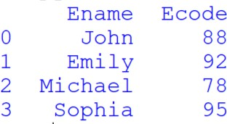 | 2

23 | Briefly explain the term URL. Also give one example of it. | 2
24 | Find the output of the following code: import pandas as pd lst1=[20,35,40]  ser1=pd.Series([20,35,40]) print(lst1+ lst1) print(ser1+ser1) | 2
25 | Clarify the role of the HAVING clause highlighting its distinctions from the WHERE clause in SQL. | 2
SECTION C
26 | Consider the following records in 'Cars' table and answer the given questions:  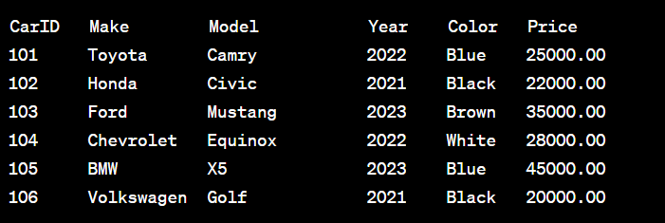  - Write SQL query that will give the output as: Blu  Bla Bro Blu  - Write command for the following:  To change the color of Model with code as 103 to 'Green'.  - How many tuples are present in the cars table?  Also identify the most suitable column of the cars table to mark as primary key column.  OR  - SELECT Make, Model FROM Cars WHERE Price > 30000.00;  - SELECT COUNT(*) AS ‘TotalCars’ FROM Cars WHERE Year = 2022;  - SELECT CarID, Make, Model FROM Cars where price<22000; | 3
27 | Complete the given Python code to get the required output as "California": import as pd  data = {'Yosemite': 'California', 'Yellowstone': 'Wyoming', 'Glacier': 'Montana', 'Rocky Mountain': 'Colorado'}  national_parks = pd.Series( ) print(national_parks ) | 3
28 | Suppose you already have “Nutrients" table in the "FOOD" database, as described  below:  Table Name: Nutrients  Column Name: Food_Item (VARCHAR) Column Name: Calorie (INT)  Write SQL statements to perform the following tasks: | 3

- Add a new column named “Plan_Start_Date” (Date) to the
"Nutrients" table.
- ii. Modify the "Calorie" column to change its data type to Float.
29 | Imagine a scenario where an individual, Alex, is concerned about his online privacy. Alex has a social media presence and frequently posts updates, photos, and comments on various platforms. Additionally, Alex frequently uses mobile apps and visits websites for shopping and information.  - Explain the concept of an active digital footprint, providing examples from Alex's online activities.  - Describe the concept of a passive digital footprint and provide examples of how  it is generated in Alex's online interactions.  - Discuss the implications of both active and passive digital footprints for Alex's online privacy and security.  OR  With reference to 3R’s, describe three essential approaches to manage electronic waste. Also, provide practical examples of how individuals can actively participate in each approach. | 3
30 | Consider the given DataFrame 'Employees': Name Employee_ID Department Alice EMP001 HR  Bob EMP002 Sales  Carol EMP003 IT  David EMP004 Marketing  Write suitable Python statements for the following operations:  - Add a column called 'Salary' with the following data: [55000, 60000, 65000, 58000].  - Include a new employee named 'Eve' with Employee_ID 'EMP005', working in the 'Finance' department, and a salary of 62000.  - Change the name of the 'Employee_ID' column to 'ID'. | 3
SECTION D
31 | Imagine you are assigned a task to manage the inventory of an online store. The store uses an SQL database to track product information in a table named 'Products.' The 'Products' table has columns for 'ProductID' (Primary Key), ‘ProductName', ‘Category’, 'QuantityInStock,' and 'PricePerUnit.'  The following scenarios represent different inventory management tasks:  - Restocking: Due to a recent sale, the 'QuantityInStock' of a product with 'ProductID' 101, named "Laptop," needs to be increased by 10 units.  - Product Availability Check: You need to check the availability of a  product named "Wireless Mouse" in the 'Electronics' category.  - Product Update: The price of all products in the 'Electronics' category should be increased by 5% to account for market changes.  - Out of Stock: Identify and list the products that are currently out of stock (QuantityInStock is 0).  For each scenario, provide the SQL statements to perform the necessary action. | 4

32 | Wizbiz Corporation is recording the quarterly sales data of its three products  through different departments. The data is as follows: Qtr1 Qtr2 Qtr3 Qtr4  Product1 3500 4200 4800 5100  Product2 2800 3100 3600 3900  Product3 1500 1800 2100 2400  The company stores this information in a CSV file named "Quarterly_Sales.csv." Mr. Raj is tasked for writing a Python program to visualise this data. He wrote the following Python code but encountered some difficulties. Help him by providing solutions to the following situations:  import pandas as pd  import as plt #line 1  df = #line 2  df.plot( ='bar', color=['purple', 'orange', 'green', 'yellow']) #line 3  plt.title ('Quarterly Sales Report') #line 4 plt.xlabel('Product')  plt.ylabel('Sales') plt.show()  - Choose the correct Python library from the following options to import in line  1:  - matplotlib  - matplotlib.plot  - py.plot  - matplotlib.pyplot  - Choose the correct option to specify the type of graph in line 3:  - type  - kind  - style  - graph  - Write suitable python statement to fetch the data from 'Quarterly_Sales.csv'  into the datafarme in line 2.  OR  Write Python statement to display total sales done in 'Qtr1' and 'Qtr2' for each product. | 4
SECTION E
33 | Attempt the following questions:  - Write a SQL query to calculate the remainder when 15 is divided by 4.  - Write a SQL query to retrieve the current year.  - Write a SQL query to extract the first three characters from the string  'Hello, World!'.  - Write a SQL query to convert the text in the 'description' column of the 'product' table to uppercase.  - Write a SQL query to display the position of '-' in values of ACC_NO column of table Bank.  OR | 5

 | Observe the given tables carefully and attempt the following questions:  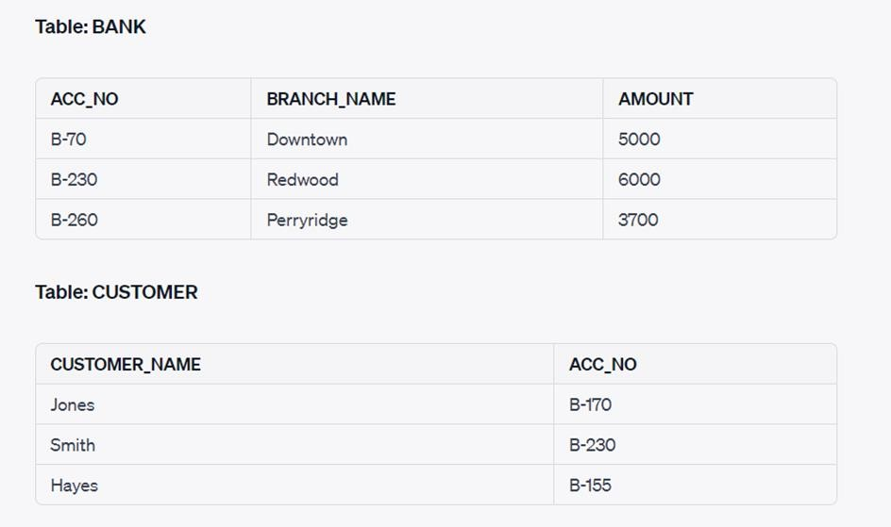  - Identify the column based on which both the tables can be related or joined. Also justify your answer.  - Write a SQL query to list names of all customers with their Amount in  ascending order:  - Write a SQL query to find the total amount of money across all branches.  - Write a SQL query to count the total records in CUSTOMER table.  - Write a SQL query to find the minimum amount in a bank. | 5
34 | A large educational campus with multiple departments and buildings is planning to establish an efficient network infrastructure to connect its various facilities. The campus comprises five main buildings, each with specific distance and computer requirements:  Distance between various buildings: Building A to Building B: 50 meters Building B to Building C: 30 meters Building C to Building D: 30 meters Building D to Building E: 35 meters Building E to Building C: 40 meters Building D to Building A: 120 meters Building D to Building B: 145 meters Building E to Building B: 65 meters  Each building hosts a varying number of computers: Building A: 55 computers  Building B: 180 computers Building C: 60 computers Building D: 55 computers Building E: 70 computers  Based on the above specifications, answer the following questions:  (a) Suggest a possible cable layout for connecting the buildings in an efficient and effective way. | 5

- Name the topology used for above cable layout.
- Suggest the most suitable place to install the server of this organisation.
- Suggest the placement of the following devices.
  - Hub/Switch
  - Repeater
- The company wants to link its head office in ‘A’ building to its Office in Sydney. What type of network this connection result into?
35 | District wise total number of houses are represented in the following table:  Dist VII Dist VIII Dist IX Dist X  40 45 35 44  Draw the following bar graph representing the number of houses in each District(Dist VII, Dist VIII, Dist IX, Dist X).  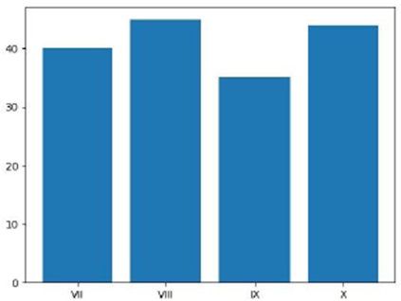  Also, give suitable python statement to save this chart in E: drive of the computer with name ‘house.png’.  OR  Write a python program to plot a line chart based on the given data to depict the weekly study patterns for all the seven days.  Day=[1,2,3,4,5,6,7]  Study_Hours=[5,4,6,5,7,8,10]  Also, give suitable python statement to save this chart in d: drive of the computer with name ‘study.png’. | 5

