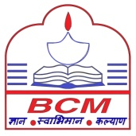
BCM SCHOOL, BASANT AVENUE, DUGRI
CLASS-V
SESSION 2025-26
TOPIC – SCIENCE PAPER PATTERN
ANSWER KEY
• Multiple choice questions
1.b) self pollination
2. b) Bisexual flowers
3. c) secondary consumer
• Assertion/Reason
4. iii) A is correct but R is incorrect.
5.i) Both A and R are correct.
• Competency based questions.
6. Plants release oxygen needed by the snail. The snail releases carbon dioxide needed by the plant. They depend on each other for gases.
7. Neha can help farmers by encouraging more insects, especially bees and butterflies, to visit the watermelon and cucumber fields. She can suggest:
1. Planting flowering plants around the field to attract pollinating insects.
2. Avoiding harmful pesticides, especially during flowering, as they can kill insects.
3. Keeping beehives near the field to increase the number of pollinators.
4. Providing water sources for insects, especially during summers.
8. No, because without anthers, the flower cannot produce pollen needed for fertilization.
9.More tigers will eat more deer, reducing deer population. With fewer deer, plants will grow better as grazing reduces.
•Case Study
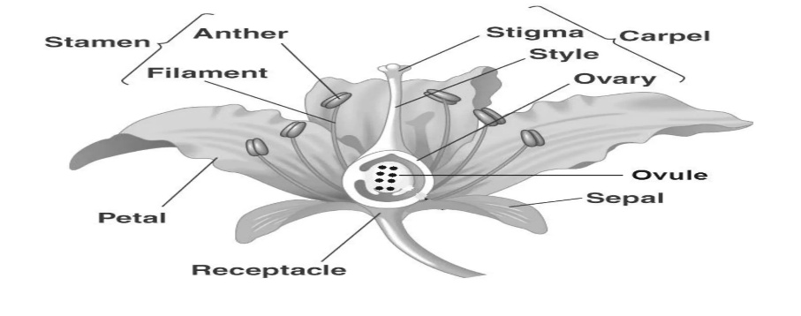
10. The male reproductive part of a flower is called the stamen.
11.The two parts of a stamen are the anther and the filament.
12.The yellow powder was pollen grains.
13.Pollen is important because it helps in pollination, which leads to seed formation.
14.The flower may not form seeds, as damaged anthers cannot produce pollen.

