Assignment -1
Class – XII
COMPUTER SCIENCE (083
Q1. | Differentiate between drop and delete commands in SQL with appropriate example.
Q2. | 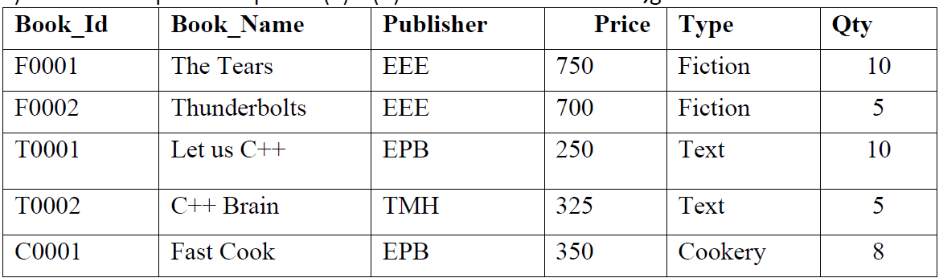  Write the o/p for the queries
a. | Select Publisher, count(*) from Book group by Publisher having Count(*)>1;
b. | Select Sum(Price) From Book Where Publisher IN (‘EPB’,’TMH’);
c. | Select Min(Qty) From Book Where Price>500;
Q3. | Write the SQL commands for the following questions (i) to (v) based on the  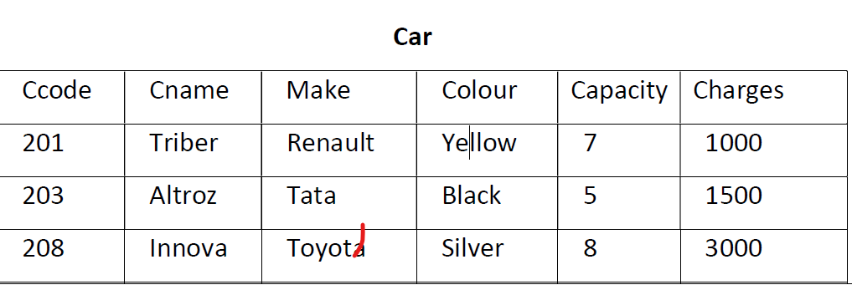  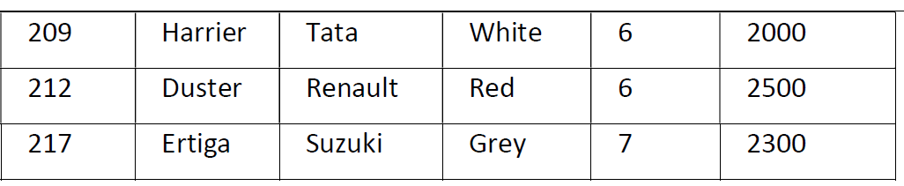  relations Car and Customer given below:
 | 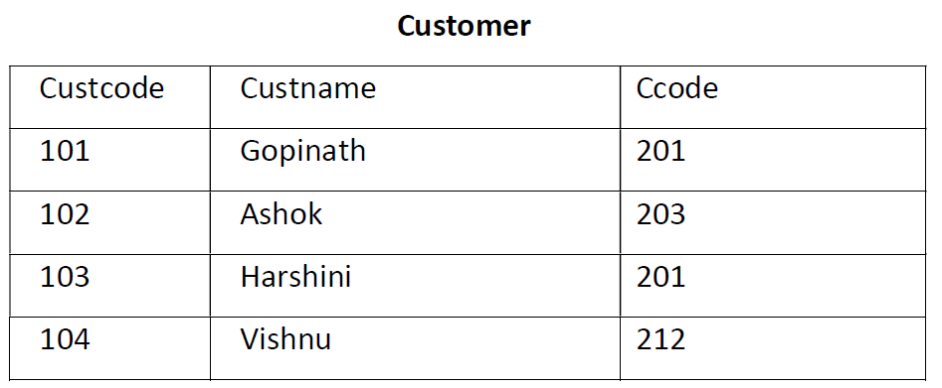
(i) To display the Names and Charges of all the Silver coloured cars.
(ii) To display the non duplicate car codes in the customer table.
(iii) To display the Minimum and Maximum car charges.
(iv) To give a discount of 10% in the car charges for existing customers (who are in the
customer table).

